|  |  |  |
| --- | --- | --- |
|  | SARVAJANIK COLLEGE OF ENGINEERING AND TECHNOLOGY |  |

## IDENTIFYING THE OPTIMAL PATH

### 

### Introduction

This report aims to provide a comprehensive analysis of three potential routes between Shree Villa Residency, Kamrej, Surat, and Sarvajanik College of Engineering and Technology. By utilizing Google Earth Pro's path feature and considering various factors, we will evaluate each route to determine the optimal path for commuting.

### Route Analysis

**Route 1: Surat-Kamrej Highway**

* Distance **:** 25.2km
* **Description:** This route follows the main highway connecting Surat and Kamrej, offering direct access and potentially faster travel times.
* **Key Points:**
  + Offers the shortest distance between the two locations.
  + May experience heavy traffic during peak hours.
  + Provides access to major amenities along the highway.

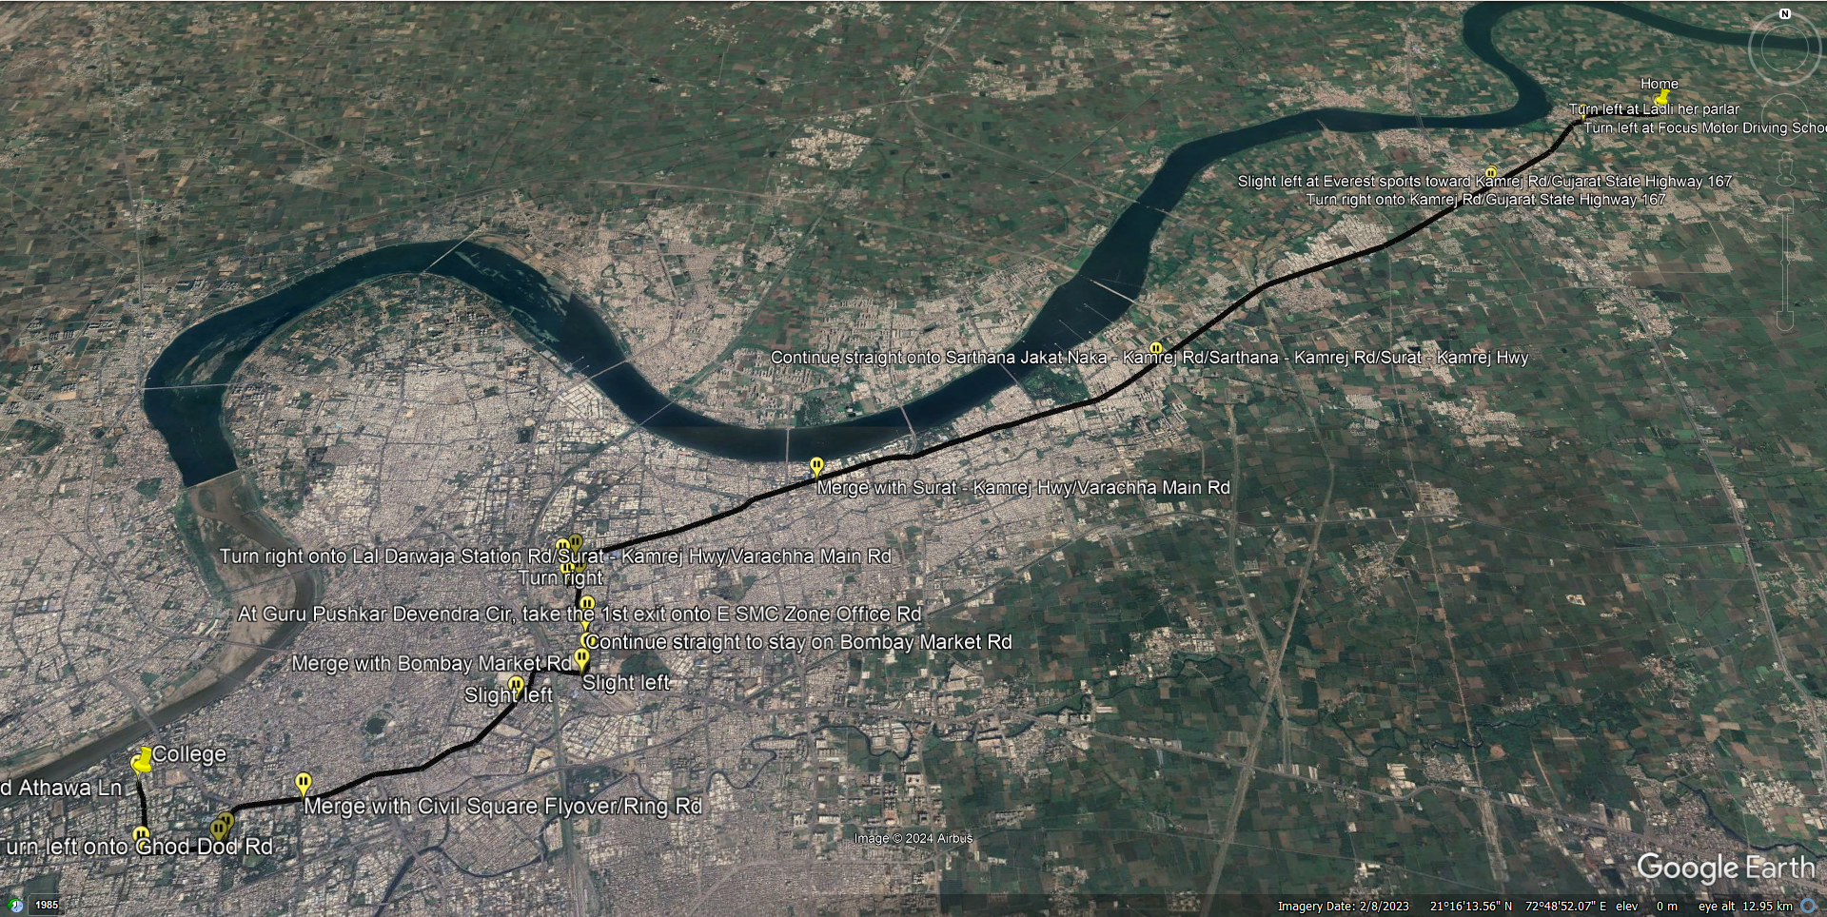

**Route 2: Valthan–Punagam Road**

* Distance **:** 29.3km
* **Description:** This route involves a detour through Valthan and Punagam, potentially adding to travel time.
* **Key Points:**
  + Offers a more scenic route with less traffic congestion.
  + Provides access to local markets and attractions.
  + May be slightly longer in terms of travel time.

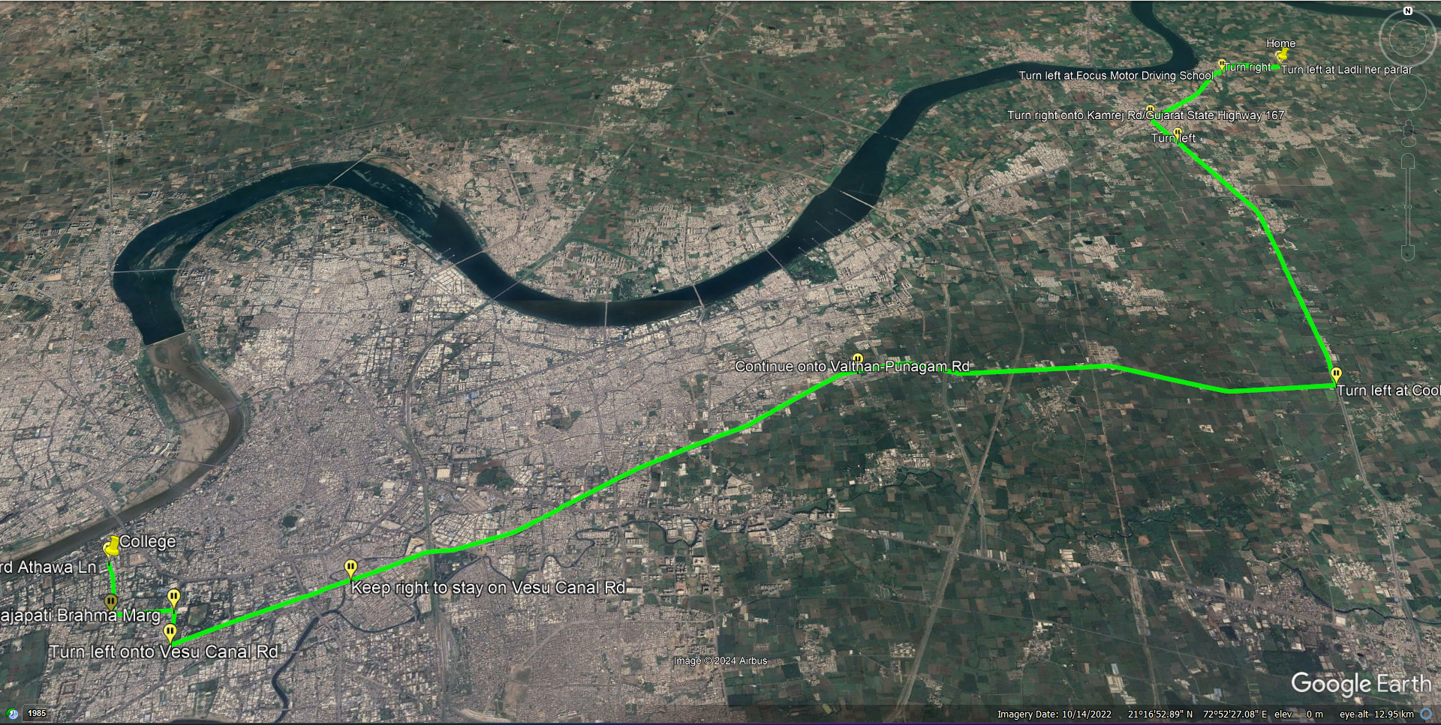

**Route 3: Sarthana Jakat Naka - Kamrej Road**

* Distance **:** 28.6km
* **Description:** This route takes a more indirect path through Sarthana and Jakat Naka.
* **Key Points:**
  + Offers a mix of urban and rural landscapes.
  + May have less traffic congestion than Route 1 during peak hours.
  + Provides access to various amenities along the route.

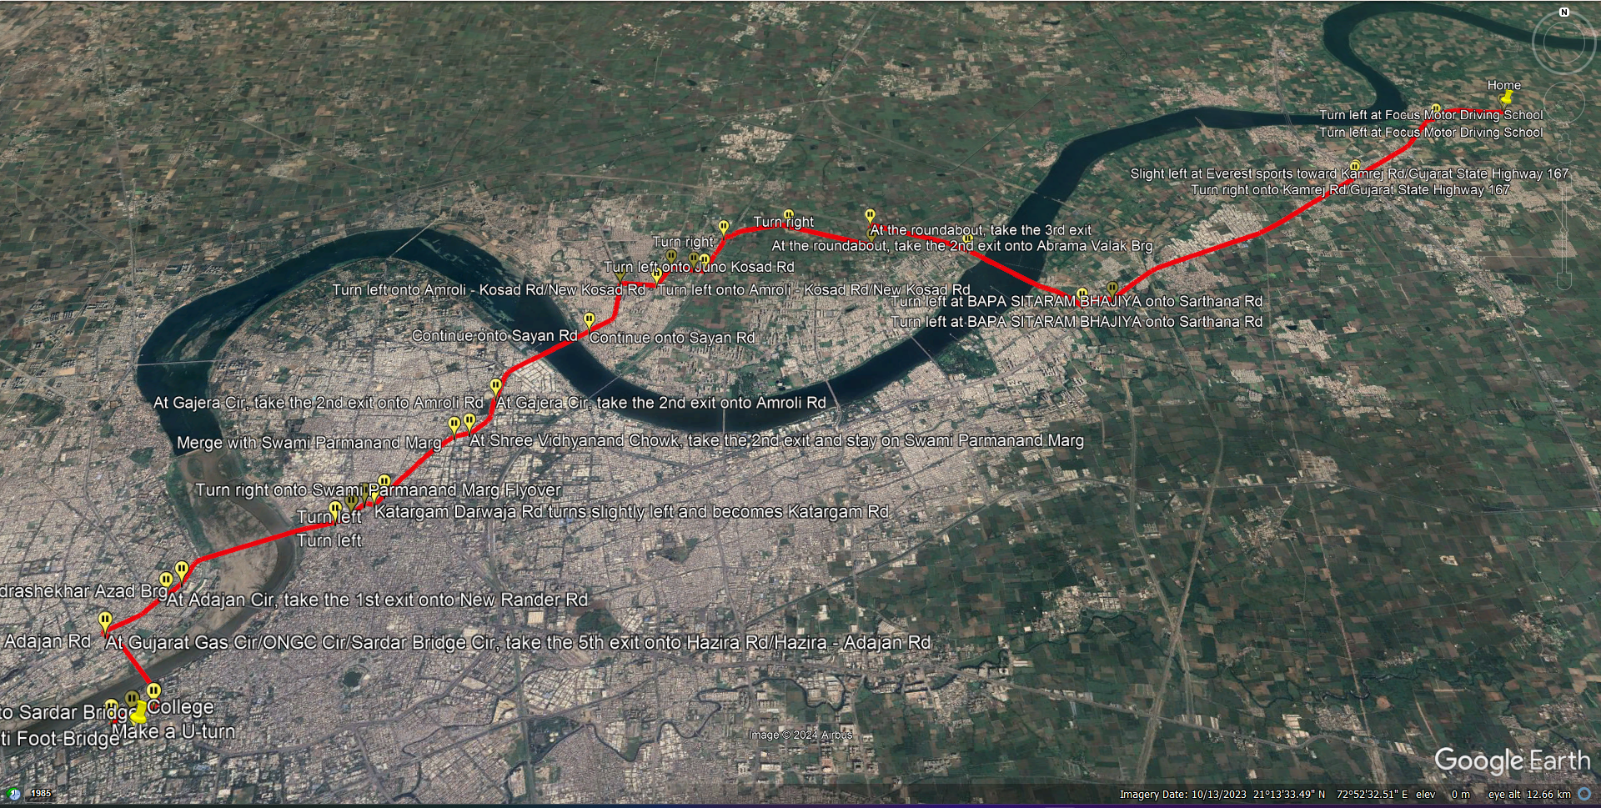

### Factors to Consider

* **Travel Time:** While distance is a significant factor, real-time traffic data can provide a more accurate estimate of travel time. Consider using Google Maps or other navigation apps to assess traffic conditions.
* **Road Conditions:** Check for any road construction, closures, or other factors that might affect travel time or safety.
* **Personal Preferences:** Consider your individual preferences for road types, scenery, or amenities along the route.
* **Public Transportation:** If public transportation is an option, evaluate factors such as frequency, travel time, and cost.
* **Optimal Path Recommendation**

Based on the analysis, **Route 1 (Surat-Kamrej Highway)** is generally the most efficient option due to its shorter distance. However, **Route 2 (Valthan-Punagam Road)** and **Route 3 (Sarthana Jakat Naka - Kamrej Road)** might be a viable alternative for those seeking a more scenic route or avoiding heavy traffic.

### Advantages

* **Visual Representation:** The path feature provides a clear visual representation of the route, helping users understand the geographical context and landmarks along the way.
* **Distance and Time Calculation:** Users can calculate the distance and estimated time of travel between locations, aiding in route planning and scheduling.
* **Alternative Routes:** Google Earth Pro offers multiple path options, allowing users to explore alternative routes and choose the most suitable one.
* **Integration with Other Data Layers:** The path feature can be integrated with other data layers, such as terrain, traffic, and satellite imagery, enhancing the overall analysis and decision-making process.

### Disadvantages

* **Dependency on Data Accuracy:** The accuracy of the path feature relies on the accuracy of underlying geographic data. Inaccuracies in the mapping data can lead to suboptimal route suggestions.
* **Limited Real-Time Updates:** Google Earth Pro's path feature may not provide real-time updates on traffic conditions, road closures, or other dynamic factors that affect navigation.
* **Complex Routes:** In some cases, the optimal path suggested by Google Earth Pro may be complex or involve unnecessary detours, requiring users to exercise their judgment.

### Applications

* **Urban Planning:** City planners can use the path feature to analyze transportation routes, traffic patterns, and connectivity between different areas of a city.
* **Tourism and Travel:** Tourists can plan their itineraries and explore the best routes to visit multiple attractions in a destination efficiently.
* **Environmental Studies:** Researchers can use the path feature to analyze wildlife migration routes, study environmental changes, and plan conservation efforts.
* **Emergency Response:** During disaster management, the path feature can help authorities plan evacuation routes and response strategies.
* **Logistics and Transportation:** Businesses can optimize delivery routes, reduce transportation costs, and improve efficiency using the path feature.
* **Personal Use:** Individuals can use the path feature for planning trips, commuting, or exploring new areas.

## 

**Conclusion**

This report has comprehensively analyzed three potential routes between Shree Villa Residency, Kamrej, Surat, and Sarvajanik College of Engineering and Technology. By considering factors such as distance, traffic conditions, and personal preferences, we have determined that **Route 1 (Surat-Kamrej Highway)** is generally the most efficient option.

However, the optimal choice may vary depending on individual circumstances and real-time traffic conditions. It is recommended to use real-time navigation apps to assess traffic and adjust your route accordingly. Additionally, exploring alternative routes and considering factors like public transportation can help you make an informed decision that best suits your needs.